**Indian Institute of Technology, Guwahati**

**ME111 Lab: Orthographic projections (Tuesday Batch)**

Draw the front view, top view and side view of following figures, in first angle projection (unless specified) and mark the appropriate dimensions.

Q. 1. Draw the orthographic views of Fig. 1 at appropriate scale. (FV, TV, LSV)

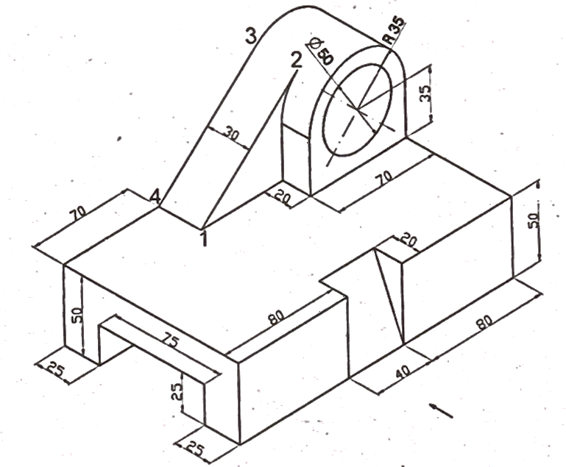

Fig. 1

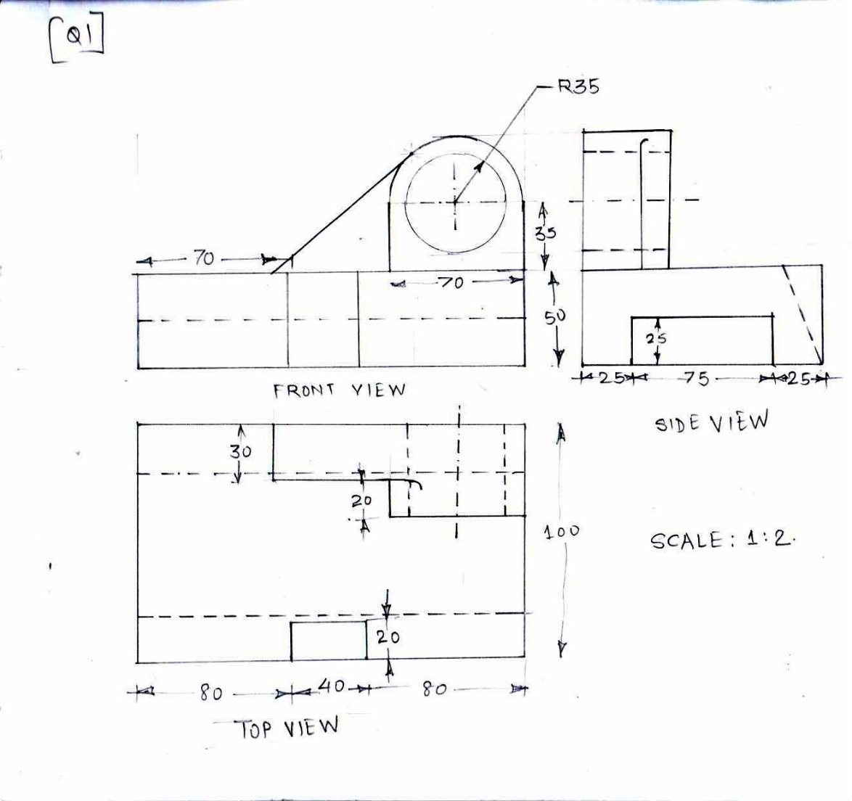

Q. 2 Draw the orthographic views of Fig. 2 at appropriate scale (THIRD ANGLE projection) (FV, TV, LSV)

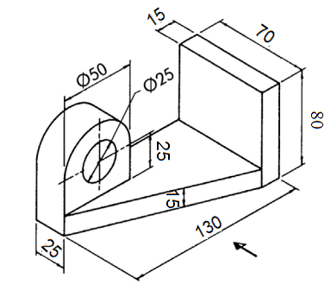

Fig. 2

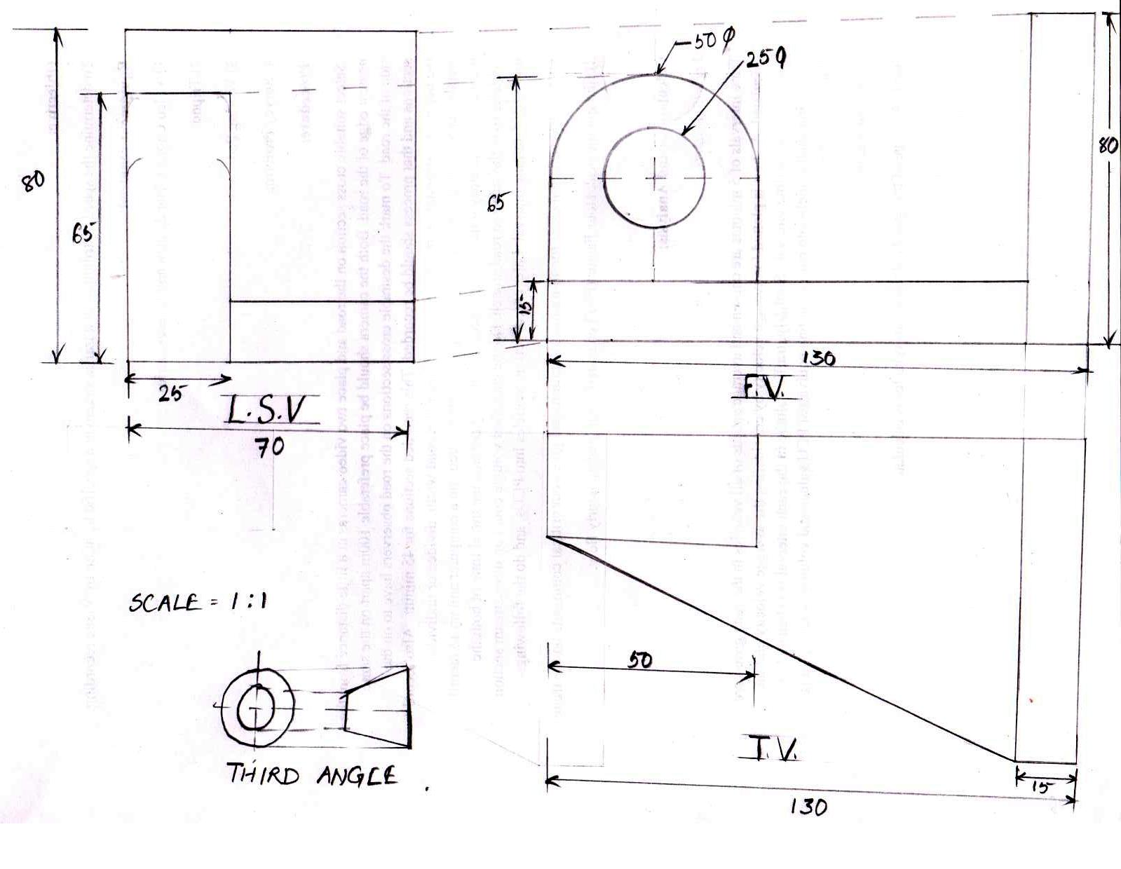

Q. 3 Draw the orthographic views of Fig. 3 at appropriate scale. (FV, TV, LSV)

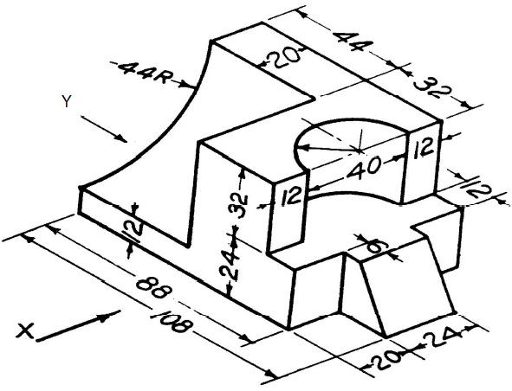

Fig. 3

